Project Design Phase-II

Data Flow Diagram & User Stories

**Data Flow Diagrams:**

A Data Flow Diagram (DFD) is a traditional visual representation of the information flows within a system. A neat and clear DFD can depict the right amount of the system requirement graphically. It shows how data enters and leaves the system, what changes the information, and where data is stored.

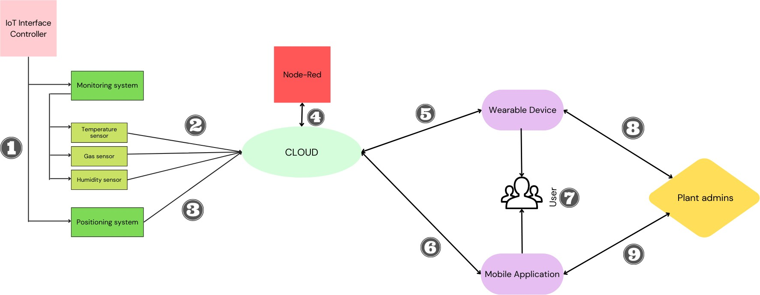

1 - IoT Interface Controller is fed the base python code which is used to run the monitoring and the positioning system. 2, 3 - Data collected from monitoring sensors and their positions are sent to the cloud.

4 - Using Node-Red, hardware devices will be wired together.

5, 6, 7 - Both the wearable device and the mobile application supply necessary data to the cloud and display final output to the user.

8, 9 - The safety admins in the plant can make changes to the wearable device and mobile application interfaces whenever necessary.

**User Stories**

Use the below template to list all the user stories for the product.

|  |  |  |  |  |  |  |
| --- | --- | --- | --- | --- | --- | --- |
| **User Type** | **Functional**  **Requirement (Epic)** | **User Story Number** | **User Story / Task** | **Acceptance criteria** | **Priority** | **Release** |
| Technician | Deployment | USN-1 | The technician must deploy all the remote sensor nodes to the hazardous areas which  need monitoring | Sensor nodes are found in areas to be monitored | High | Sprint-1 |
| Technician | Data Gathering | USN-2 | The sensor nodes collect the required critical data and send it to the cloud | Critical parameters like temperature, gas present are monitored | High | Sprint-1 |
| Technician | Development | USN-3 | The wearable device, mobile application and their user interface needs to be developed | These elements are used to send out the alerts | High | Sprint-1 |
| Working personnel | Registration | USN-4 | As a user, I can register for the application by entering the credentials given by the  industry | I can access my account / dashboard | High | Sprint-1 |
| Working personnel | Login | USN-5 | As a user, I can enter my employee details to access the wearable device | I can use the wearable  device while working in the plant | High | Sprint-1 |
| Working personnel | Alert system | USN-6 | The users need to receive alerts in times of a hazard either through the mobile application or through the wearable device | Timely and accurate alerts are sent to both the  mobile application and the wearable device | High | Sprint-2 |
| Plant administrator | Admin Dashboard | USN-7 | The admin can send additional information  to the working personnel through the admin dashboard | The UI can be altered by the admin | Medium | Sprint-2 |
| Plant administrator | Alert system | USN-8 | The admin can send out manual alerts whenever necessary to the personnel through the mobile app and the wearable  device | The admin can view the collected data and send out alerts | Medium | Sprint-3 |
| Customer Care Executive | Maintenance | USN-9 | The deployed sensors and the wearable device need to be checked for faulty conditions | Finding faulty conditions and documenting them to avoid potential lawsuits | Medium | Sprint-4 |
| Customer Care Executive | Updates and bug fixes | USN-10 | Necessary updates to the monitoring algorithm should be made as per  requirements of the future | To make updates to match with the changing  times | Low | Sprint-4 |